Aromatic compounds differ from other cyclic compounds in such a way that they contain at least one ________
A. Carbonium ion
B. Hydrogen atom
C. Nitrogen ring
D. Benzene ring
ANSWER: D
Alicyclic compounds are also called ________.
A. Homocyclic
B. Benzenoids
C. Non-benzenoids
D. Heterocyclic
ANSWER: C
All such organic compounds having open chain structure of carbon are called
A. Aromatic
B. Aliphatic
C. Alicyclic
D. None of the above
ANSWER: B
All closed chain compounds possessing a hexagonal ring of six carbon atoms are called
A. Aliphatic compounds
B. Alicyclic compounds
C. Carbocyclic compounds
D. None of the above
ANSWER: C

Which of the following is a heterocyclic compound?
A. Benzene
B. Pyridine
C. Toluene
D. Chlorobenzene
ANSWER: B

Organic compounds are very large number because of
A. Tetravalency of carbon
B. Catenation
C. Ability of carbon to form multiple Bond
D. All the factors mentioned above
ANSWER: B

The given three hydrocarbons are
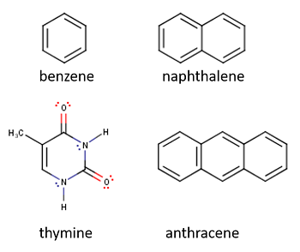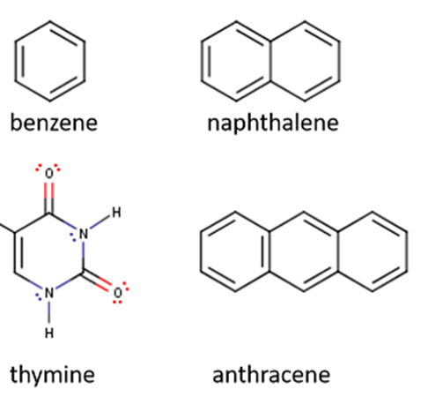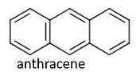
A. Alicyclic hydrocarbons
B. Aromatic hydrocarbons
C. Acyclic hydrocarbons
D. Heterocyclic hydrocarbons
ANSWER: B
In which of the following category, this compound fall?
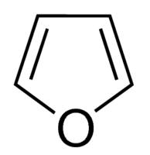
A. Aliphatic
B. Heterocyclic
C. Non-benzenoids
D. Closed Chain
ANSWER: B
When methane burns in oxygen _______ is produced.
A. CH₄
B. CO₂
C. CO
D. C=O
ANSWER: B
Organic compounds contain:
A. Nitrogen and carbon
B. Hydrogen and oxygen
C. Carbon and hydrogen
D. Nitrogen and hydrogen
ANSWER: C
Closed chain containing carbons atoms are also called as _____________ hydrocarbons
A. Cyclic
B. Cyclic
C. Aromatic
D. None
ANSWER: B

The main sources of these arenes are _________
A. Petroleum
B. Biogas and petroleum
C. Petroleum and coal tar
D. Natural gas
ANSWER: C

Benzene is an example of
A. Aromatic compound
B. Aliphatic compound
C. Non-benzenoid
D. None of these
ANSWER: A
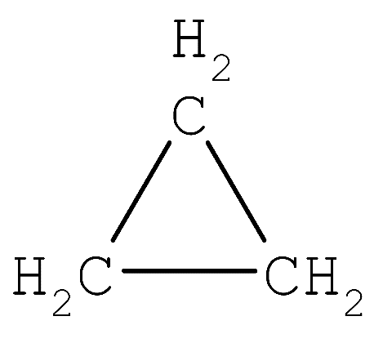
A. Aromatic compound
B. Aliphatic compound
C. Alicyclic
D. None of these
ANSWER: C

It is an example of
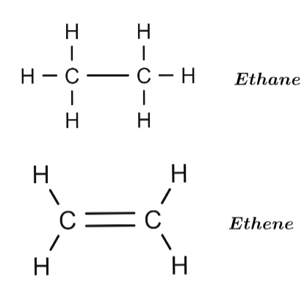
A. Aromatic compound
B. Aliphatic compound
C. Alicyclic
D. Non-benzenoid
ANSWER: C

